**Conduct Post-Transition Review**

**Module Description**

In this module you will be attending a meeting to look at potential improvements for FERS.

**Scenario**

A follow-up meeting is held between the Development Team Manager and the Project Manager to determine if there are opportunities for improving the quality of future releases by the project team. Initial ideas are documented and then it is decided that a meeting will be held between the project team to get their thoughts and feedback. Your team is in attendance.

**ADM Activity Context Diagram**

Application > 5700 Execute Test > T5749 Transition Product-Tested Application

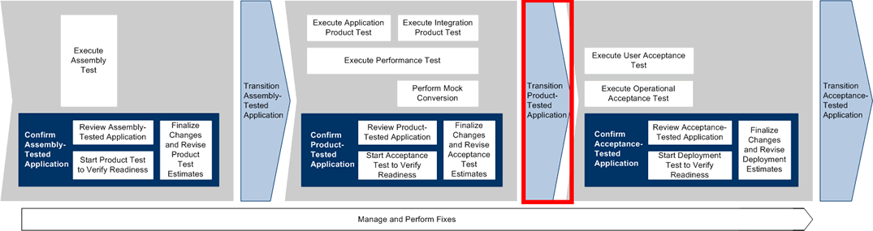

**Roles**

|  |  |  |  |
| --- | --- | --- | --- |
| **Role** | **ADM Task** | **ADM Responsibility** | **Description** |
| Manager | T5749 Transition Product-Tested Application | Management Oversight | Provides guidance on the Project Status Report. Solicits feedback from the team. |
| Team (All) | T5749 Transition Product-Tested Application | Additional Performer | Provides feedback on how the project team performed and ideas for how to improve the team's performance. |

**Participant Instructions**

1. Release 1 is in production! Congratulate yourself for a job well done!

2. The Project Manager (and Development Team Manager) will lead a discussion on how Release 1 was conducted.

3. Find opportunities to answer any questions offered by the Project Management.

4. Ask any process, project or product-related questions that you may have during this time.

**Hints and Tips**

* Consider taking notes on the feedback that the managers and other team members give.
* Prepare your own questions in advance to ask the managers, in particular those centered on how to be successful on future projects in the developer or analyst role.